Fake or Scammer!

1. Pieter Mouthan

Person 1:

* 1. Pieter Mouthaan
  2. Developer, entrepreneur
  3. From the Netherlands
  4. Master's in Business Administration and Entrepreneurship
  5. Self employed
  6. Created Photo A

First of all there wasn't any picture given for this person identity, that's why it's difficult for me to find the actual Pieter Mouthan depending on this identity information.Although, there can be lots of Pieter Mouthan with the same identity and same educational background. Moreover, I found a couple o f people with the name Pieter mouthan who have similar identity backgrounds.But the identity might be a scam.

Pieter Mouthan a Dutch entrepreneur, CEO of **Dutch Power Company (DPC)**, but not related to AI development but also a developer of dutch power company DPDC.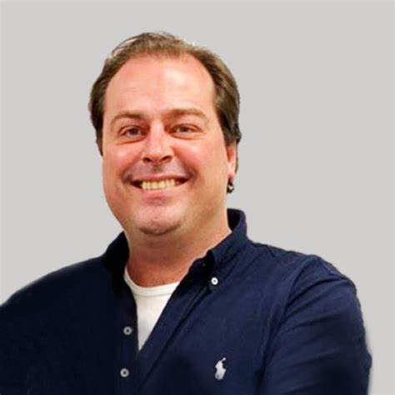

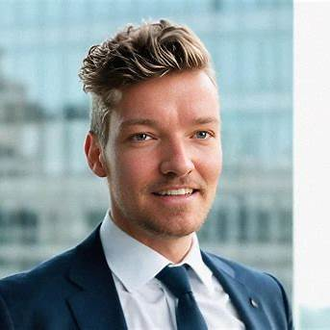

Pieter Mouthan is a Dutch entrepreneur and self-taught developer who created **Photo AI**. Dutch entrepreneur and self-taught developer renowned for creating several successful startups. He developed Photo AI, an AI-driven photography service that enables users to generate realistic images and videos using artificial intelligence.

1. Michael Moore

a.Owns a business

b.Lives in Manhattan

c.Widower for 7 years+

d.Has a daughter that lives in Madrid, Spain with her husband that is a doctor

e.Has twin granddaughters

f.Has a German shepherd named Jack

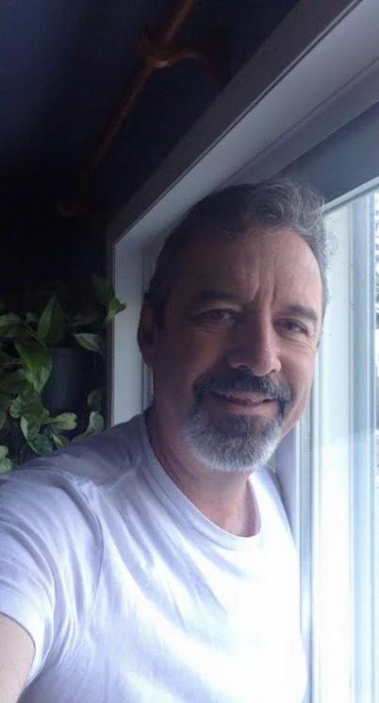 I didn't find someone with this picture named Michael Moore. Maybe he doesn't even have that name or information! So I would say he is a fake or scammer.

One the other way!,

I found one people according to this information but with a few unmatched identity

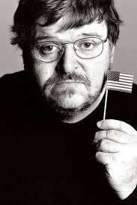 According to the identity speaking, Michael Moore who was widower for 7 years since 2014 and he has two daughters not granddaughter and one of his daughters lived in Madrid but didn't find any information about granddaughters and also he owns a business.

1. Kenneth Dean

Lives in Washington D.C., USA

VP at a real estate development and property management company

 He is a real person with the same identity I would say. I found him on Linkedin and instagram as well with the same profile and the same profession. But there can be more people with the same name but with this photo and profession this person is real.